EXPERIMENT 6

Aim: To simulate a handoff scenario in a mobile network and visualize the process using Figma.
Procedure:
- Open Figma and create a new design file.
- Draw two cell towers and label them Base Station A and Base Station B.
- Add a mobile phone icon between the two towers.
- Draw arrows from the mobile phone to both base stations.
- Show the phone moving from Station A toward Station B.
- Add labels such as “Connected to A,” “Signal Weak,” “Handoff,” and “Connected to B.”
- Use different colors to show the connection before and after handoff.
- Use Prototype mode to connect frames and simulate the phone moving between the two stations.
OUTPUT:
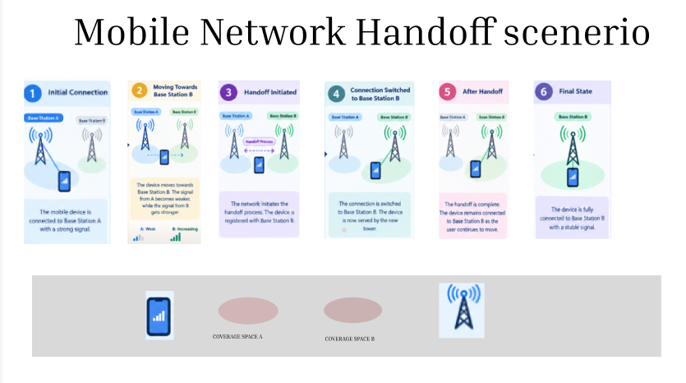
FIGMALINK:
https://www.figma.com/design/ED1qcVpNfWi2Zuft4amJyZ/Untitled?node-id=7-2&p=f&m=draw
RESULT: The mobile network handoff scenario was visualized successfully in Figma, demonstrating how a mobile device transfers its connection from one base station to another.

